SLOVAK UNIVERSITY OF TECHNOLOGY IN BRATISLAVA

FACULTY OF INFORMATICS AND INFORMATION TECHNOLOGY

**Gymbro**

Gym Companion

**Martin Szabo**

2023

Introduction

Gymbro – gym companion is a desktop companion application for gym enthusiasts who want to find the best gym for their workout needs in their area.

1. Description

The basic idea is that in the app you will be presented with a map of a city and on the map, you can see all gyms that are present in the city. You will be able to click the gym and look up following data about the gym:

* Equipment of the gym,
* User’s reviews,
* Photos of the gym and the area around it,
* All membership tiers and their respective prices,
* Timetable when the gym opened,
* A time map how busy is the gym during open hours,

Also, what trainers work there, how much money they charge for a workout session and an evaluation informing the user what is the gym’s price/amount of equipment ratio.

It will also show you how far the gym is from your current location and a time estimate how long will you the user travel there. When you click a gym there will be sections and one section will contain links to main gym web page and a google maps link to the path from current location to the gym.

1. 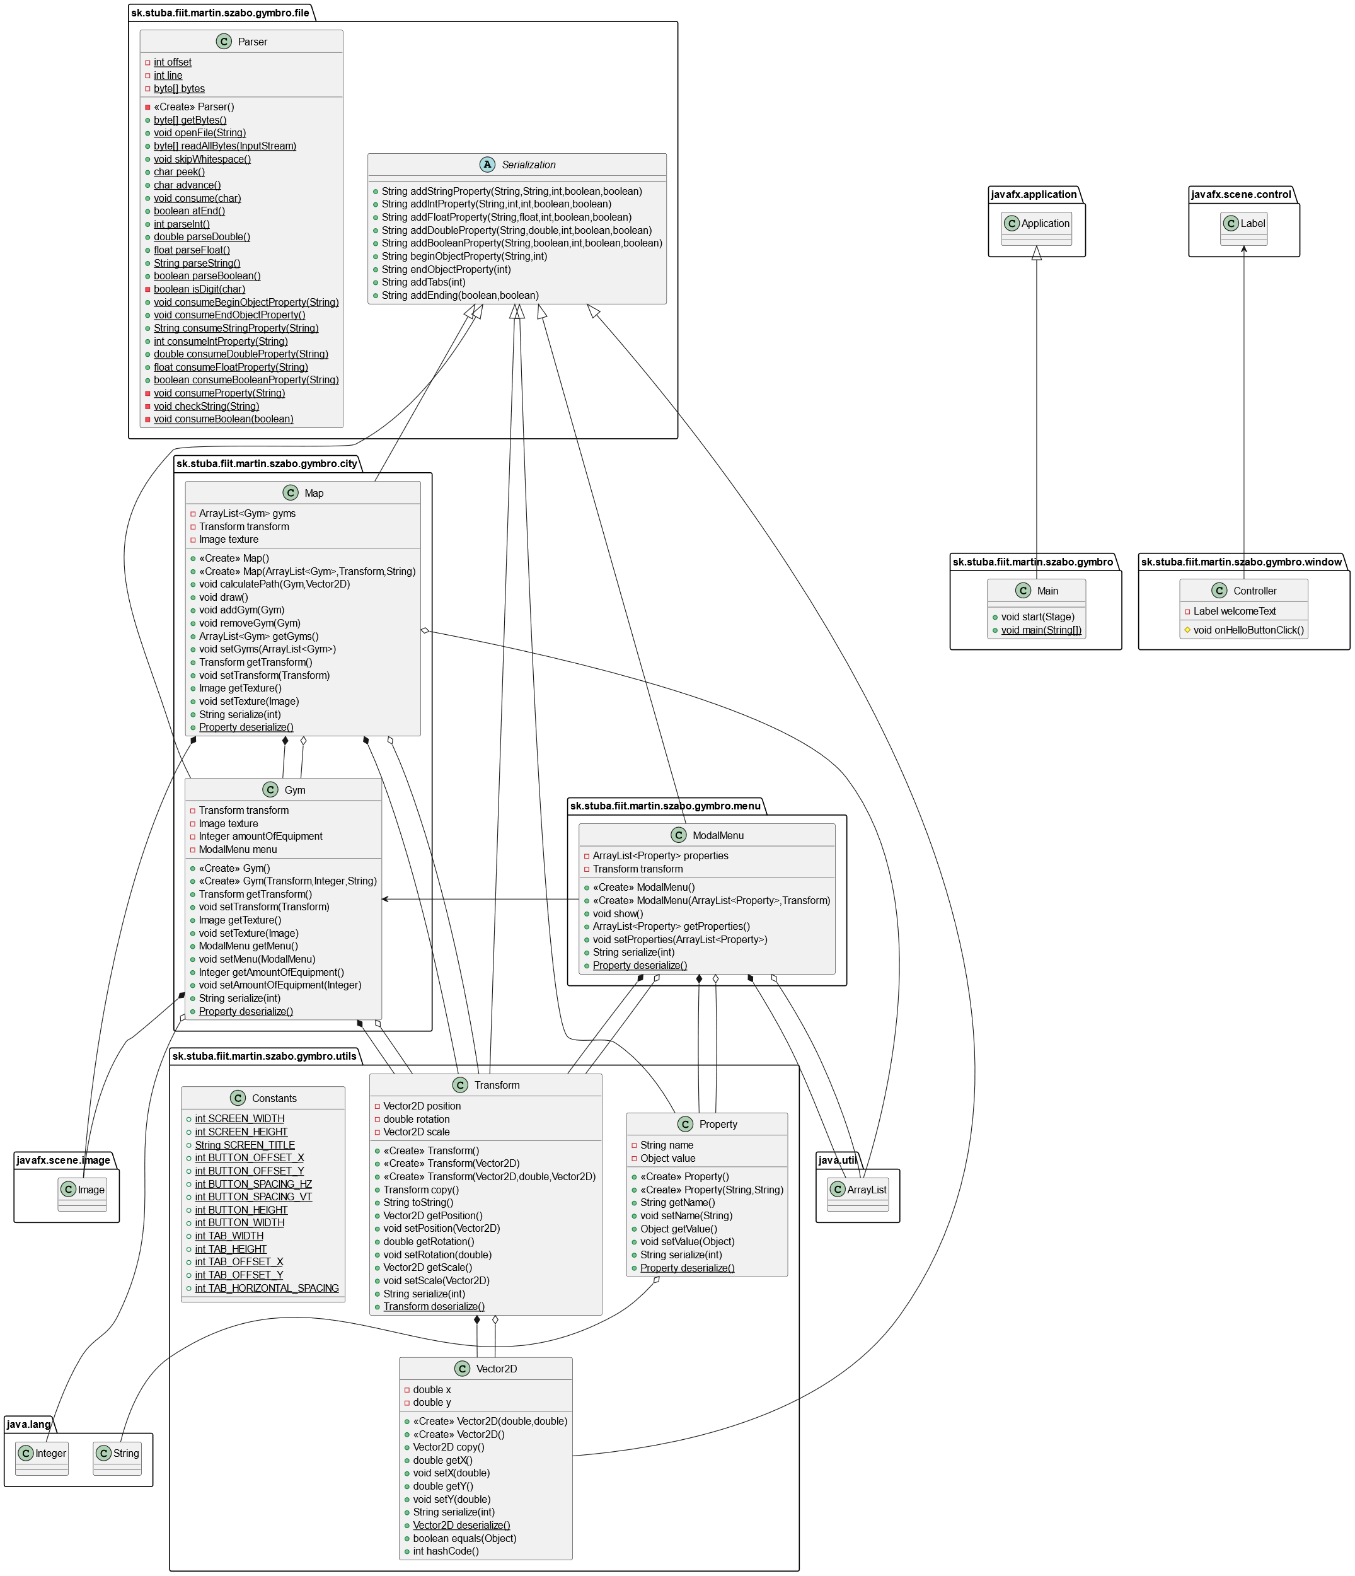Diagram